# Assignment 5: Project

*Vidar Heltne, Ole Andre Heggdal, Fredrik Opstad Sætran, Fredrik Mikael Valderhaug,   
Thomas Demyx Tennøy.  
IE101912 Objectorientert programmering*

## Project introduction

The Local radio station “Gloppen NærRadio” is in need of a system to keep track of all their music (on CD’s, Tapes, and HDs etc.), jingles, and commercials advertisements as well as self-produced material like news and journalist reports.

## Design

In an early stage of the project, we decided to make a GUI for the UI. We made most of the GUI in Netbeans and some of its code. However, despite that we decided to go with text IO in the end. The reason for this was mostly the lack of time.

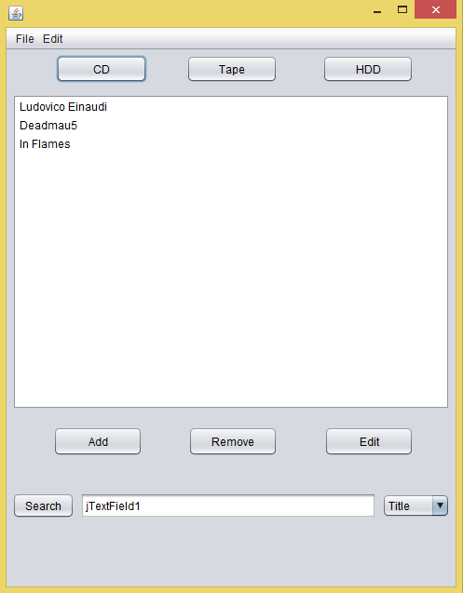A little of what could have been.

What we ended up with was a series of menus and submenus to maneuver the functions of the system.

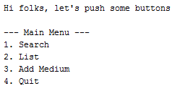The main menu: The search menu: The list menu:

